**Que:- Demonstration of Basic Calculator in C#.net Windows Programming.**

using System;

using System.Collections.Generic;

using System.ComponentModel;

using System.Data;

using System.Drawing;

using System.Text;

using System.Windows.Forms;

namespace calculate

{

public partial class Form1 : Form

{

public Form1()

{

InitializeComponent();

}

private void btnadd_Click(object sender, EventArgs e)

{

int a,b,c;

a =Convert.ToInt32(txtfno.Text);

b =Convert.ToInt32(txtsno.Text);

c = a + b;

txtres.Text=c.ToString();

}

private void btnsub_Click(object sender, EventArgs e)

{

int a, b, c;

a = Convert.ToInt32(txtfno.Text);

b = Convert.ToInt32(txtsno.Text);

c = a - b;

txtres.Text = c.ToString();

}

private void btnmulti_Click(object sender, EventArgs e)

{

int a, b, c;

a = Convert.ToInt32(txtfno.Text);

b = Convert.ToInt32(txtsno.Text);

c = a * b;

txtres.Text = c.ToString();

}

private void btndiv_Click(object sender, EventArgs e)

{

int a, b, c;

a = Convert.ToInt32(txtfno.Text);

b = Convert.ToInt32(txtsno.Text);

c = a / b;

txtres.Text = c.ToString();

}

}

}

**Output:-**

**Addition:**

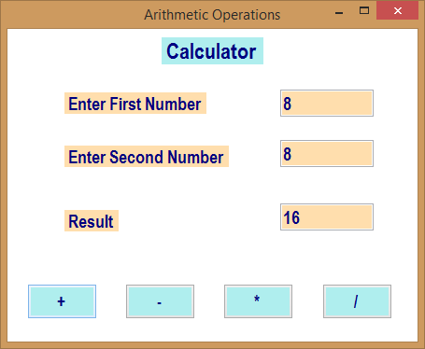

**Subtraction:**

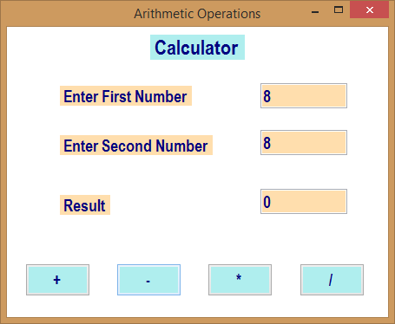

**Multiplication:-**

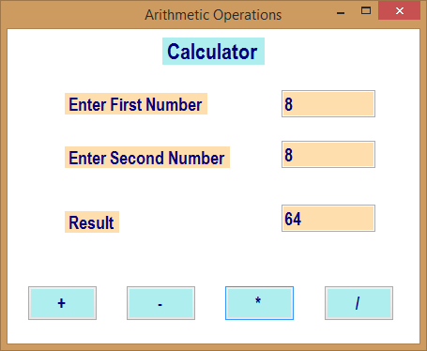

**Division:**

